CALL FOR SUBMISSIONS:
Community engagement for inclusive rural transformation and gender equality
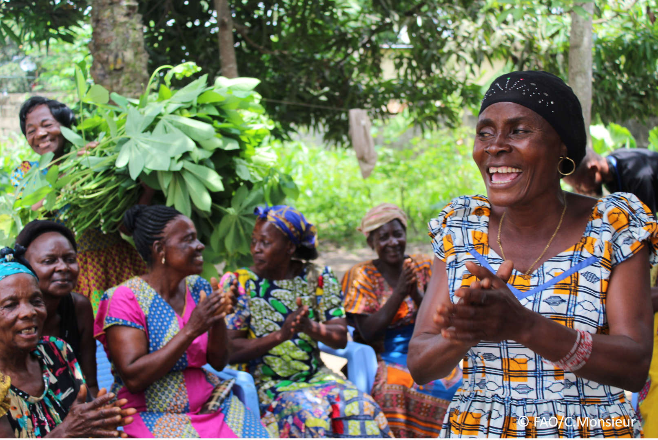
The objective of this call for submissions is to collect good practices, experiences, and lessons learnt on the use of community engagement for inclusive rural transformation and gender equality. The initiative, organized by the Rural Transformation and Gender Equality Division (ESP), seeks to gather insights from a diverse range of contributors, both within FAO and from external stakeholders. Its goal is to share knowledge, foster learning, and guide the scaling up of community engagement and community-led collective action to leave no one behind. The call builds on FAO's past efforts in this area, such as the Community Engagement Days series of webinars.
The call for submissions is open until 27 November 2024.

How to take part in this call for submissions:
To take part in this Call for submissions, please register to the FSN Forum, if you are not yet a member, or “sign in” to your account. Please review the topic note to understand the criteria we are considering for this call. If you wish to learn more about community engagement, you may refer to the background document. Once you have completed this submission template, upload it in the box “Post your contribution” on the call webpage, or, alternatively, send it to fsn-moderator@fao.org.
Please keep the length of submissions limited to 1,500 words and feel also free to attach relevant supporting materials.

Template for submissions

Contact person | Name: Hilawit Gebrehanna  Director Behavior and Social Change  Organization/Unit: CARE, Gender Justice  Country: United States, GA  Email address: hilawit.gebrehanna@care.org  Name: Suniti Neogy  Organization/Unit: CARE, Gender Justice  Country: India  Email address: suniti.neogy@care.org
Name/title of the good practice | Girls in Action (Learning Communities on the Move)
Where is the good practice taking place? (Multiple selection allowed) | ☐ Europe and Central Asia  ☐ Latin America and the Caribbean  ☒ North Africa and Near East  ☒ Sub-Saharan Africa  ☒ Asia and the Pacific  ☐ North America  ☒ Global
Affiliation | ☐ Farmer and producer organizations  ☐ Trade Union  ☒ Informal community-based, farmer-based or self-help group  ☐ Research and academia  ☐ Government  ☐ Local/traditional authorities  ☐ Private Sector  ☐ Civil Society Organization  ☐ Intergovernmental Organization (e.g. UN system, World Bank)  ☐ Resource Partner/Donor  ☐ Other (please specify)
In which sector(s) and context (s) have you used this community engagement good practice? (Multiple selections allowed) | ☒ Education  ☒ Health and Sanitation  ☒ Food production in agrifood systems (please also tick the sub-categories)  ☐ Crop cultivation  ☐ Fisheries and aquaculture production  ☐ Livestock  ☐ Forestry  ☐ Agroforestry  ☐ Horticulture  ☐ Apiculture (beekeeping)  ☐ Agroecology and sustainable farming practices  ☐ Soil and water management  ☐ Other: ____________  ☐ Post-production in agrifood systems (please also tick the sub-categories)  ☐ Processing and value addition  ☐ Marketing and retailing  ☐ Transporting  ☐ Food loss and waste  ☐ Packaging  ☐ Storage  ☐ Distribution  ☐ Other _________  ☒ Gender Equality  ☐ Climate Action  ☐ Citizenship and Governance  ☐ Social Protection  ☒ Humanitarian and protracted crisis  ☐ Conflict resolution, peace and resilience  ☐ Digital innovation  ☐ Other sector (please specify) _________
Who are the financial partners supporting this good practice, if applicable? | Kendeda Fund
- In a few sentences, summarize your community engagement good practice. Girls in Action is CARE’s model aimed at shifting social norms.. It empowers girls to collectively express their choices and opinions as a movement advocating for their rights. By working with mentors and role models from their communities, girls go through a four-step process to determine what issues they want to address. Together, they receive support to implement their actions, monitor progress, and evaluate their efforts.
- What problem(s) or challenge(s) does your good practice aim to address through community engagement?
Girls, especially in rural communities, face many barriers to choosing their own path and many of these are rooted in social norms which restrict their rights. Not being valued equally alongside their brothers, being expected to have decisions made for them by men, or needing to seek permission or have a male companion when leaving home are just a few of the norms girls may face — and these can have far-reaching implications for their ability to go to school, earn an income, make decisions about their body, or even choose who and when they marry. Each community and society have norms specific to its unique context, which is why girl-led action is so important. It ensures actions address the specific challenges holding girls back by centering their expertise and engagement. Girls in Action aims to create a space that nurtures and empowers girls as leaders and decision-makers.
- Describe your good practice in more detail. Include the main guiding principles, the desired changes or outcomes you aim to achieve (Theory of Change), and the key phases of implementation.
This good practice centers on empowering adolescent girls to lead interventions that challenge harmful social norms in their communities. The guiding principles include: trusting girls' capabilities and lived experiences, providing structured mentorship rather than direct leadership, ensuring girl-led planning and decision-making, implementing comprehensive risk mitigation strategies, and building structured allyship with parents, boys, and community leaders. The practice moves beyond traditional behavior change communication approaches by positioning girls as agents of change rather than just beneficiaries, enabling them to identify priority issues, plan activities, and lead public events that make harmful norms visible and promote positive alternatives.
The Theory of Change focuses on transforming restrictive gender norms by building girls' individual and collective agency while simultaneously shifting community-level social expectations. Key implementation phases include: 1) Trust-building with program staff and budget holders to enable genuine girl leadership, 2) Mentorship support that guides without directing, allowing girls to find their own solutions, 3) Facilitated planning where girls identify priority norms to address and design public activities, 4) Structured allyship development with boys, parents and community leaders through focused sessions on gender equality and supporting girls' initiatives, 5) Risk assessment and mitigation planning led by girls with ally support, and 6) Implementation of community events that challenge norms through activities like sports matches, cooking competitions, and public discussions.
These strategies both expand girls’ individual and collective agency, connect girls of different ages and backgrounds, abilities/disabilities, and help them understand the dynamics at play in girls’ lives. The implementation of the activities over the recommended course of six months, at a minimum, to 18 months, at a maximum, supports girl led programming.
- Who are the key actors and stakeholders involved in the design and implementation of the good practice, and what are their respective roles? Consider local partners, government, local authorities, community radios, civil society, research, the private sector, etc.
The key actors in CARE's girl-led social norms shifting practice are organized in concentric circles of support around adolescent girls as the primary change agents. At the core, adolescent girls lead the planning and implementation of activities, supported by mentors (older girls or young female staff) who provide guidance while respecting girls' decision-making autonomy. Program staff manage resources and facilitate rather than direct. The next circle includes critical community allies - parents, adolescent boys, community leaders, and school committees - who undergo structured allyship training to support girls' initiatives and help manage potential backlash. The outer circle comprises institutional actors like program team providing technical frameworks, women's movements offering broader networks, and local authorities granting needed permissions. Success depends on transforming traditional power dynamics so that all stakeholders support rather than direct girls' leadership.
The model can be implemented by a women’s rights organisation or youth focussed organisation or combined with any program that works with adolescents.

- How does your intervention ensure inclusivity and equal and meaningful participation within the community?
Describe how your intervention includes and engages different groups within the community. Consider aspects like gender, age, ethnicity, disability status, livelihoods, and other specific conditions (e.g., people living in prolonged crisis, migrants, refugees). Explain how your intervention engages diverse segments of the rural community. Highlight the specific actions or strategies you use to reach these groups. If applicable, mention if your intervention uses specific approaches such as gender-responsive, gender-transformative, intersectionality, or other methods to ensure inclusivity and gender equality.
The Girls in Action/LCOM model prioritizes inclusivity and meaningful participation through several deliberate strategies. The Learning Communities on the Move (LCOM) model, combined with the Tipping Point methodology, demonstrates remarkable adaptability across diverse contexts - from South Asia to West Africa and the Middle East, serving various populations including internally displaced people in Syria and college students in Ethiopia. The model is intentionally designed to be practical and user-friendly, adaptable across multiple sectors including education, food and nutrition, economic empowerment, child marriage prevention, and humanitarian protection. The initiative ensures diverse participation by actively identifying and engaging girls from various backgrounds, making specific adaptations for accessibility - for example, in Niger, the program was modified with illustrated materials for girls with lower literacy levels and translated into local languages. The model explicitly addresses intersecting vulnerabilities by considering age (balancing younger and older adolescent girls), education status (adapting materials for different literacy levels), and socioeconomic conditions (working through existing platforms like CARE's Village Savings & Loan Associations). Additionally, structured allyship engages multiple stakeholders across the community - including parents, boys, religious leaders, and local authorities - while maintaining girls' leadership and decision-making power. This comprehensive approach ensures that marginalized girls aren't just included but are positioned as leaders in challenging harmful norms, while building support systems that enable their sustained participation and leadership across various cultural and socioeconomic contexts.
- By using community engagement, what results and impacts have your good practice achieved?
Please provide specific examples and evidence demonstrating the effectiveness of your intervention, focusing on both qualitative and quantitative outcomes related to livelihoods and well-being improvements.
The Girls in Action model has achieved significant impacts in four key areas:
First, it demonstrated immediate norm shifts through girls successfully challenging mobility restrictions, transforming gender roles (e.g., through boys/men participating in cooking competitions), and increasing girls' safety and acceptance in public spaces. Second, it enhanced girls' leadership capabilities as they learned to plan events, manage budgets, conduct community research, and engage with authority figures. Third, it created meaningful community-level changes by building effective alliances with parents, boys, and local leaders, while changing perceptions about girls' capabilities. Finally, it contributed to systemic changes by establishing new models for girls' collective action and creating pathways for their participation in decision-making spaces. The practice showed that girl-led approaches, when supported by community engagement, can accelerate norm change more effectively than traditional programming.

- Among these results, has the good practice led to improvements in terms of gender equality, women’s empowerment, and/or social inclusion?
Describe the behavioral changes in terms of gender that the good practice promotes, emphasizing agency, leadership, and participation in local governance. Include efforts to challenge discriminatory norms and unequal power dynamics. Highlight also how the intervention has supported the well-being (including psychological resilience) of marginalized groups and enhanced their inclusion and participation in decision-making processes.

In Nepal, evaluation results demonstrate increased mobility and self-efficacy, improved sexual and reproductive health (SRH) knowledge and significant increases in communication and negotiation with parents, and participation in decision-making for girls participating in the initiative. Evaluation results in Bangladesh demonstrate a significant reduction in endorsement of control over girls by family, and justification of girl-beating; and significant increases in girls’ positive attitudes regarding gender roles, SRH knowledge, mobility, confidence in negotiation skills, and self-efficacy. In Niger and Mali, the project documented increases in awareness of girls’ rights, improved confidence, and increased agency for decision-making among adolescent girls. Results from Northwest Syria show gradual improvements in agency and relations. Overall, Tipping Point’s evaluations demonstrate a reduction in the risk of child marriage for girls participating in the program.

- What key challenges did you encounter while implementing the community engagement activities, and how did you address them?
Include any resistance from communities, pushback, or issues related to unequal power dynamics, if applicable.
The girls identify their issues, prioritize one issue collectively and work together to address the issue. Challenge: Program staff try to lead girls. It takes consciousness and practice to let young girls lead and adult step back and play the role of true mentor without patronizing. We used risk mitigation and management approach led by girls and learnt that in teh fragile contexts in Noth west Syria, some of the activities were not safe so adapted them, for example, teh individual surveys teh girls were supposed to conduct were done in groups as an FGD rather than individual survey going to households. In Niger, due to low literacy levels, strategies were adapted for supporting girls in data collection and analysis.
- What are the key lesson learned from your community engagement and good practice?
This is a completely girl led girl managed model. The biggest lesson learnt that when the intervention is led by community, it has a strong ownership of the programming by the community. They can generate and manage resources carefully, understand the dynamics of the social norms’ strength, understand risks closely and are the best mitigators and planners. We also learnt that girl led monitoring and evaluation as well as girl led risk mitigation and management is effective and sustainable.
- Has this practice been replicated in the same context or in different contexts?
What are the required conditions to replicate and adapt the practice in another context/geographical area?
Yes, it has been replicated with adaptations for the contexts in:
- India, Nepal and Bangladesh in South Asia,
- Niger and Mali in West Africa
- Ethiopia in East and Central Africa
- Northwest Syria in the Middle East region
- How sustainable are the results achieved by this good practice?
Describe the key elements that need to be in place to make the initiative sustainable, including enabling environment (legal and policy frameworks and institutions), local ownership, accountability, etc.
In Bangladesh, the Mohila Porishad adapted teh model to scale it in other districts of Mohila Porishad programming with girls. CARE-UNFPA global partnership: CARE formalized a memorandum of understanding with UNFPA that, due to Tipping Point’s strategic engagement, emphasized a focus on adolescent and gender transformative programming. This opened the door for expanding technical influencing at country-level, joint resource mobilization for sexual and reproductive health systems change implemented alongside government counterparts, and CEFM integration in emergency settings.
In Nepal the Girls Formed a Girls Rights Forum and generated resources from teh local government to continue their activism.
- Based on the conversations FAO held during the Community Engagement days, a definition of community engagement for empowerment was proposed:

“Community engagement for empowerment and community-led collective action can be defined as an inclusive and participatory process that enables community members to become active agents to lead change in decisions affecting their lives, health, and environment modeling as a positive deviant to lead social norms change in their communities. This process develops their capacity to achieve sustainable outcomes for improved rural livelihoods. Embracing a rights-based approach, it prioritizes the agency and participation of all community members, regardless of gender identity, sexual orientation, age, ethnicity, caste, socioeconomic status, political affiliation, migration status, or ability/disability. Indeed, inclusive approaches recognize the complexities of overlapping marginalization and discrimination that can exclude different community members from decision-making processes and implement strategies to foster their participation, agency and empowerment.”

We invite you to contribute to this definition. What would you add or change? Please share your thoughts, suggestions, and any additional elements you believe are crucial for a comprehensive understanding of community engagement approaches aimed at community-led collective action for inclusive rural transformation, people’s empowerment and gender equality.

- Based on your experience, what gaps or areas for improvement still need to be addressed in the field of community engagement?
What we learnt is that the community who will be affected by the change, need to identify what issues they want to address, the planning and execution is led by community, monitored and evaluated by community for sustainable change.
- What do you think is FAO's role in the field of community engagement? How can FAO support and enhance interventions like yours, if applicable? Consider aspects such as policy advocacy, capacity development, funding, technical assistance, knowledge production and sharing, and fostering partnerships.
FAO can support this model implementation by providing funding support to a Women’s Rights organisation/ Youth or Women Led organisation that can play a mentoring role for girls can be prioritised. Capacity can be developed for the WRO as a mentor for girls who would take lead, build and demonstrate trust in girls' abilities and provide support. Build capacities of the WRO to work as an ally for the girls and build strong advocacy strategies to change their realities and issues towards a more equal society.

Link(s) to specific references about your good practice (e.g. reports, communication products, videos, articles) | Please include attachment(s) or add here link(s) to documents/videos/podcasts/other with specific references.  - Mentors’ Training & Facilitation Package: A model for girl led activism and movement building  - Girls’ Activist Package: A model for girl led activism and movement building  - Learning Communities on the Move (LCOM) Model Overview  - Girl-Led-Social-Norms_9.20.21.pdf  - Bangladesh: Innovation-Brief_Girl-led-activism_2_pager_Final.pdf  - West Africa: B_TP_Scale_Up_Learning_Brief_6.29.22.pdf  - https://www.care.org/wp-content/uploads/2023/08/TP_RMM-Girl-led-programming_v4.pdf  - Manuals – Tipping Point Initiative- CARE

The call for submissions is directly aligned with the thematic components of collective action within FAO's Programme Priority Areas (PPAs), specifically Better Life 1 (Gender Equality and Rural Women’s Empowerment), Better Life 2 (Inclusive Rural Transformation) and Better Life 3 (Agriculture and Food Emergencies).

